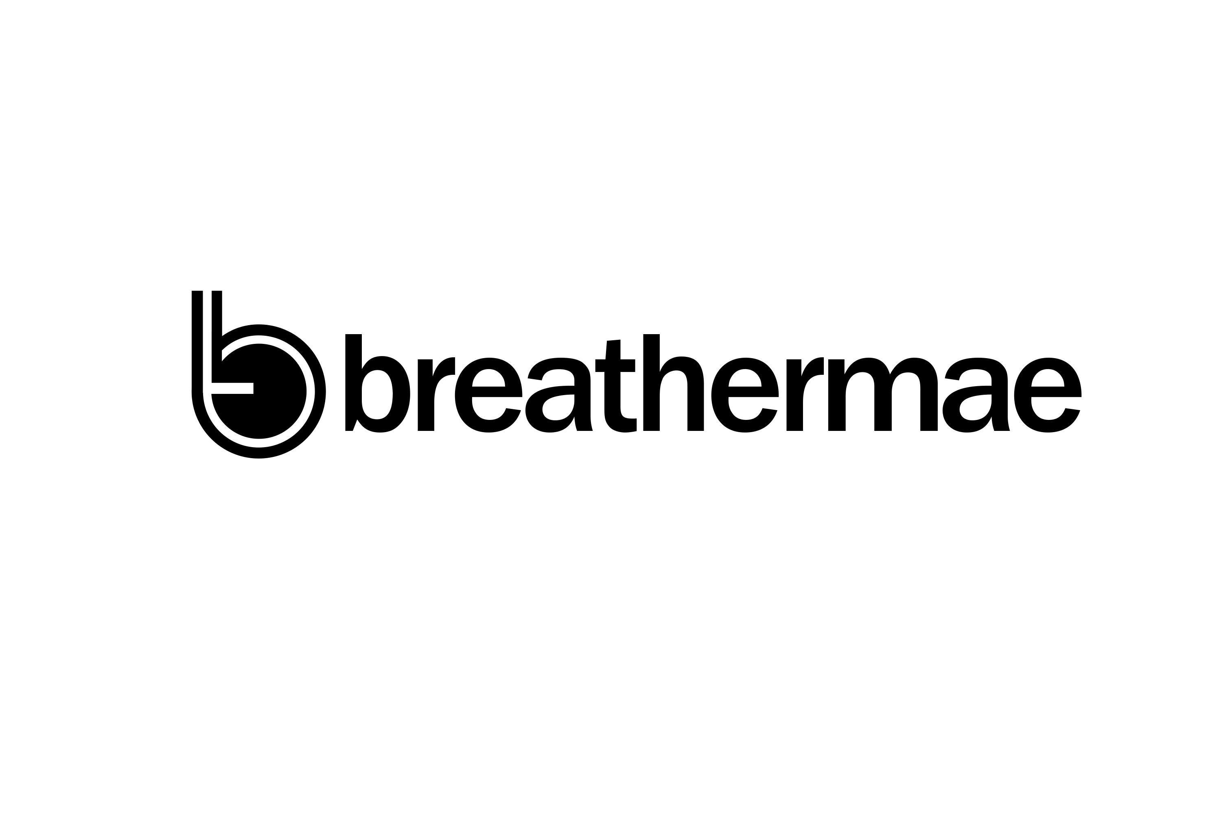
Voice Capture SOP

Voice-Based Neuro-Autonomic Regulation Analysis Engine
Standard Operating Procedure (SOP v1.0)

1. Purpose
To standardize the collection of voice samples for the extraction of signal-derived indicators related to:
• Vocal stability
• Breath-speech coordination
• Neuromuscular consistency
• Temporal pacing and rhythm
• Regulation under structured vocal tasks

This protocol ensures repeatability, signal integrity, and cross-participant comparability.

2. Scope
Applies to:
• All Breathermae participants (consumer, athlete, clinical, corporate)
• All voice capture sessions (baseline + longitudinal)
• All environments (in-clinic, remote, mobile app)

3. Compliance Positioning (CRITICAL)
This system:
• DOES NOT diagnose emotional or medical conditions
• DOES NOT classify emotions
• DOES NOT map frequency to emotional states

This system:
• Measures signal stability, coordination, and variability
• Feeds into BSI™ → Neural-Emotional Load domain
• Contributes to Adaptive Capacity modeling

4. Equipment Requirements
Minimum Standard
• Smartphone (iOS/Android) OR calibrated microphone
• Recording format: WAV (preferred) or high-quality PCM
• Sample rate: ≥ 44.1 kHz
• Bit depth: 16-bit minimum (24-bit preferred)

Environmental Requirements
• Quiet room (≤ 40 dB ambient noise)
• No background music or TV
• No echo-heavy spaces (avoid large empty rooms)

5. Participant Preparation
Participant must:
• Sit or stand upright (no slouching)
• Keep head in neutral position
• Maintain consistent microphone distance (~6–8 inches)
• Avoid:
• chewing gum
• eating during recording
• heavy breathing from recent exertion
• Hydrate normally (water allowed)

6. Pre-Capture Baseline
Step 1 — Silence Capture
• Record 10 seconds of silence
• Participant remains still and quiet

Purpose:
• Establish noise floor
• Capture environmental baseline

7. Voice Capture Sequence (MANDATORY ORDER)
Step 2 — Sustained Phonation (Vowel Stability)
Instruction:
“Take a comfortable breath and hold the sound ‘ahhh’ as steadily as you can.”

• Duration: as long as comfortable
• Repeat: 2 trials
• Rest: 3–5 seconds between trials

Captured Features:
• Amplitude stability
• Micro-tremor
• Breath control
• Onset/decay patterns

Step 3 — Rhythmic Counting Task
3A — Natural Pace
“Please count from one to ten in your normal speaking voice.”

3B — Slower Controlled Pace
“Now count from one to ten again, slightly slower, while staying natural and relaxed.”

Captured Features:
• Temporal spacing
• Rhythm consistency
• Motor coordination
• Repetition stability

Step 4 — Standardized Reading Passage
Primary Script (REQUIRED)
“I am reading this passage in a calm, natural, and steady voice. I will speak at a comfortable pace and breathe normally throughout the recording. I will not try to change my tone, emotion, or rhythm. I will allow each sentence to flow naturally and pause only where punctuation occurs. My goal is to remain clear, relaxed, and consistent from beginning to end. This recording is capturing how my voice functions in this moment through breath, timing, steadiness, and control.”

Duration: ~25–35 seconds

Captured Features:
• Prosody
• Articulation consistency
• Breath phrasing
• Stability over continuous speech

Step 5 — Post-Capture Silence
• Record 5 seconds silence

Purpose:
• Capture trailing noise floor
• Analyze post-vocal decay

8. Total Session Duration
~ 60–90 seconds per participant

9. File Naming Convention
Format:

BM_VOICE_[ParticipantID]_[YYYYMMDD]_[Session#]

Example:

BM_VOICE_10294_20260330_S1.wav

10. Metadata Capture (REQUIRED)

Each recording must include:
• Participant ID
• Date & time
• Device type (iPhone, Android, mic model)
• Environment type (home, clinic, gym, office)
• Position (seated/standing)
• Recent activity:
• Rested
• Post-exercise (<30 min)
• Hydration status (normal / dry mouth)

11. Quality Control (QC) Criteria

ACCEPT Recording If:
• No background interruptions
• Voice clearly audible
• No clipping/distortion
• All steps completed in correct order

REJECT & RECAPTURE If:
• Background noise spike
• Participant laughs, coughs excessively, or stops mid-task
• Microphone distance changes significantly
• Script not followed

12. Data Output (Engineering Integration)

Each sample feeds into:

Feature Extraction Layers
• Frequency decomposition
• Amplitude variance
• Harmonic stability
• Temporal spacing
• Pause distribution
• Signal entropy

Derived Outputs
• Vocal Stability Index
• Breath Coordination Score
• Temporal Regulation Score
• Signal Variability Profile

These map into:

→ BSI™ Neural-Emotional Load
→ Adaptive Capacity Modeling
→ SCI™ Coordination Analysis

13. Longitudinal Capture Standard

To ensure comparability:
• Use same script every time
• Maintain same time of day (preferred)
• Maintain same environment (if possible)
• Maintain same device type

Recommended cadence:
• Baseline
• Weekly (high-resolution tracking)
• Monthly (general tracking)

14. Administrator Script (Verbatim)

“Please speak in your normal voice. Do not try to change your tone, emotion, or pace. Maintain a steady and comfortable rhythm. Keep the microphone at a consistent distance. We are capturing how your voice functions, not what you are expressing.”

15. Failure Modes to Monitor
• Overperformance (participant “acts” voice)
• Whispering or over-projection
• Inconsistent pacing
• Forced breathing patterns
• Environmental contamination

16. Version Control
• SOP Version: 1.0
• System: Voice-Based Neuro-Autonomic Regulation Analysis Engine
• Platform: Breathermae BSI™ Integration

Next Step (Recommended)

From here, I strongly recommend we build three additional components to complete your system:

1. Data Schema (Backend Ready)

Exact JSON structure for:
• raw audio
• extracted features
• BSI mapping

2. Feature-to-BSI Mapping Table

How each signal metric contributes to:
• Neural-Emotional Load
• Regulation vs Dysregulation (non-diagnostic)

3. Result Output Language (User-Facing)

Compliant phrasing like:
• “Your voice shows increased variability under sustained output”
• NOT “stress” / NOT “anxiety”

